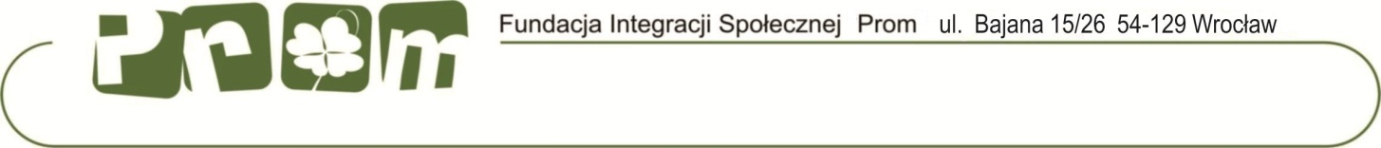
Preferred Kindergarten: (choose number from description of the project)
EVS QUESTIONAIRE
Candidate Name:
Country: Slovakia
Sending Organization Name: Mladiinfo Slovensko, evs@mladiinfo.sk, Ondrej Mäsiar
Age:
Personal Information

Name
Surname
Address |  | Number
Postal Code |  | Town
Country
Phone |  | Fax
Mobile |  | e-mail
Date of Birth |  | Place of Birth
Nationality |  | Sex | female | male
Emergency contact details
Name:

Address:

Email: mobile:

Motivation to be a volunteer:

1. Please describe your motivation and expectations .
Please write exactly what you would like to learn/ gain/ develop thanks to participation in EVS.
What you can offer to the hosting organization and to the people/ children who you will work with.

2. Can you give us ideas for activities about your culture/ other (exe :art, music, theatre...) that you would like to organise during volunteer time? Please write as much as you have in your mind, this will help us to construct better plan of work for you.

3. Yours skills and knowledge, that you think can be useful for the Project.

4. Please describe your personality in the following categories: strong and weak sides, values which you believe, your attitude to changes in life.
5. Please put in order of preference:
Intellectual work
Working alone
Heavy manual work
Daily contact with the public/ children
Team work
Working outdoors
Light manual work
Art work
Other: ?

6. Please describe your experience in work within group of children/ youth. If you have had any, how long it took and what did you do with this group/ what was your role ?. Give examples of activities that you organized or supported.

7. What do think what kind of difficulties you can face during the stay In foreign country. How you will deal with them. What are your fears and hopes.
Please describe your previous international experience?

8. What do you know about Poland (people, customs, culture)?
What you would like to see in Poland?

9. How do you spend free time?

10. Please write something about your family, friends and life in your country.

11. Other Information about yourself that you would like that the project team know ?

12. What do you plan to do after EVS?

Health, special requirements: ( serious accidents, illness, allergies, psychological problems, disabilities addiction, depression, epilepsy?) Do you require any special medication?

Dietary requirements:

Do you smoke?

