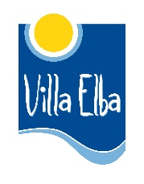

Erasmus+: Youth in Action | EUROPEAN VOLUNTARY SERVICE | Zagorje ob Savi, Slovenia

Call for volunteers
ReCreate Yourself

Volunteer: volunteers from Slovakia and Finland, 18-30 years old, motivated, no previous experience needed
Project activity dates: 9 months (starting from 15th March - 14th December 2018)
Venue: Zagorje ob Savi, Slovenia
Hosting and coordinating organization: Mladinski center Zagorje ob Savi (Slovenia)
Sending organizations: Villa Elba (Finland) and Mladiinfo Slovensko (Slovakia)

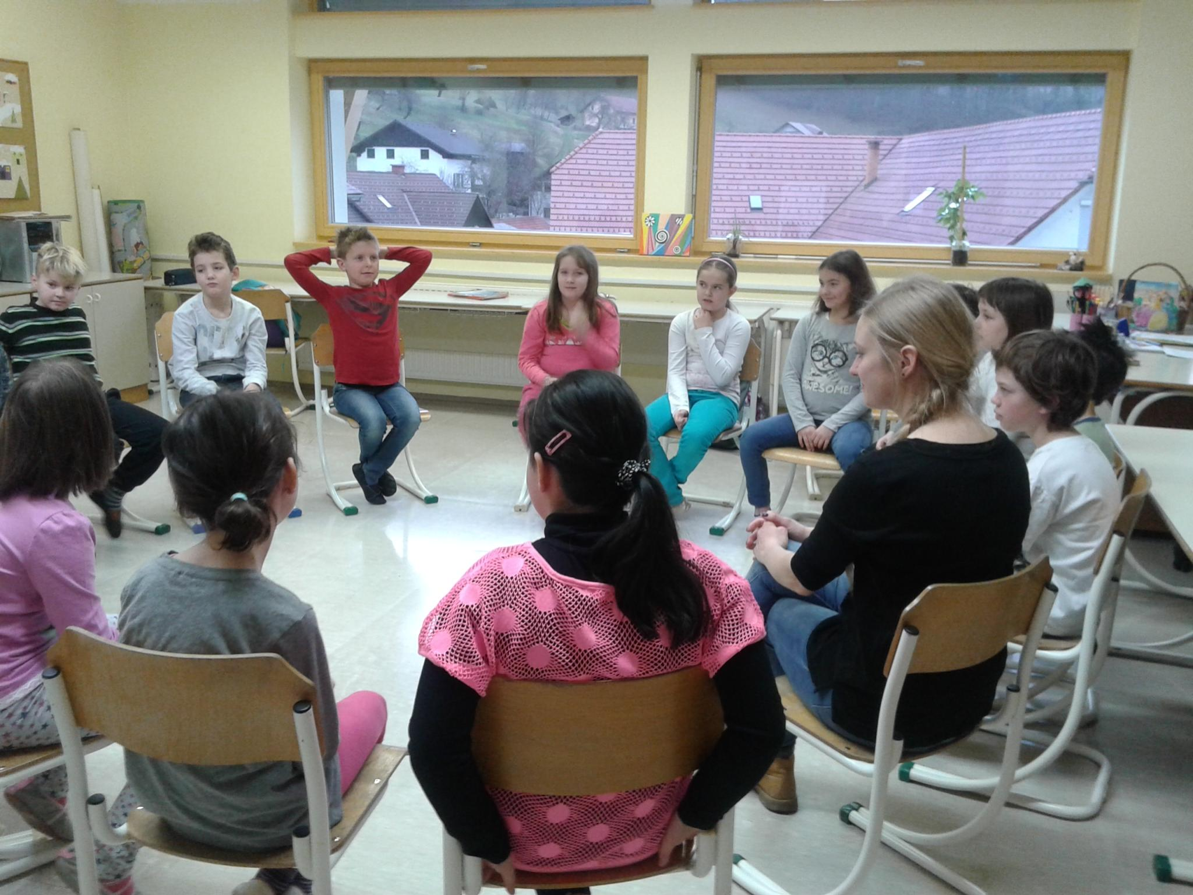
Project description:
The main focus of the project is to strengthen intercultural learning, creativity and social inclusion and with this widen employability of youth. Volunteers will support youth center with activities, events and festivals for the local community in daily center, in the street and in other organizations. They will try themselves in different roles and learn how to do multimedia products. They will cooperate in different team environments and work on different projects, some of them organized on local, regional or national level. They will share their cultures and open space for different topics. They will learn to respect differences, people, how to overcome prejudices and make compromises. Besides, there will be space for volunteers’ ideas.

Activities:
- organiziation, development and execution of activities and events of youth center
- work in daily center and street work
- teamwork with EVS and local volunteers, students and youth workers
- individual work
- project management learning
- practising non-formal methods of learning
- getting conflict resolution skills
- cooperation with other organizations (school, kindergarten, intergenerational center and center for people with dissabilities), their employees, users and volunteers
- photo, video, blog, promotional and other products
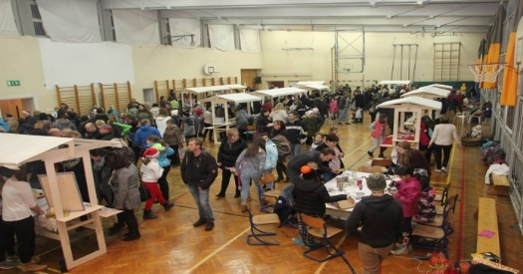
- organizing activities on different topics
- getting to know Slovenian and other cultures
- promoting EVS, E+, non-formal education and volunteering in the community
- implementation of a personal project
- space for volunteer's ideas

We offer:
A great opportunity to learn with the support of well-experienced team of youth workers as well as very colourful free time with our local volunteers.

Costs:
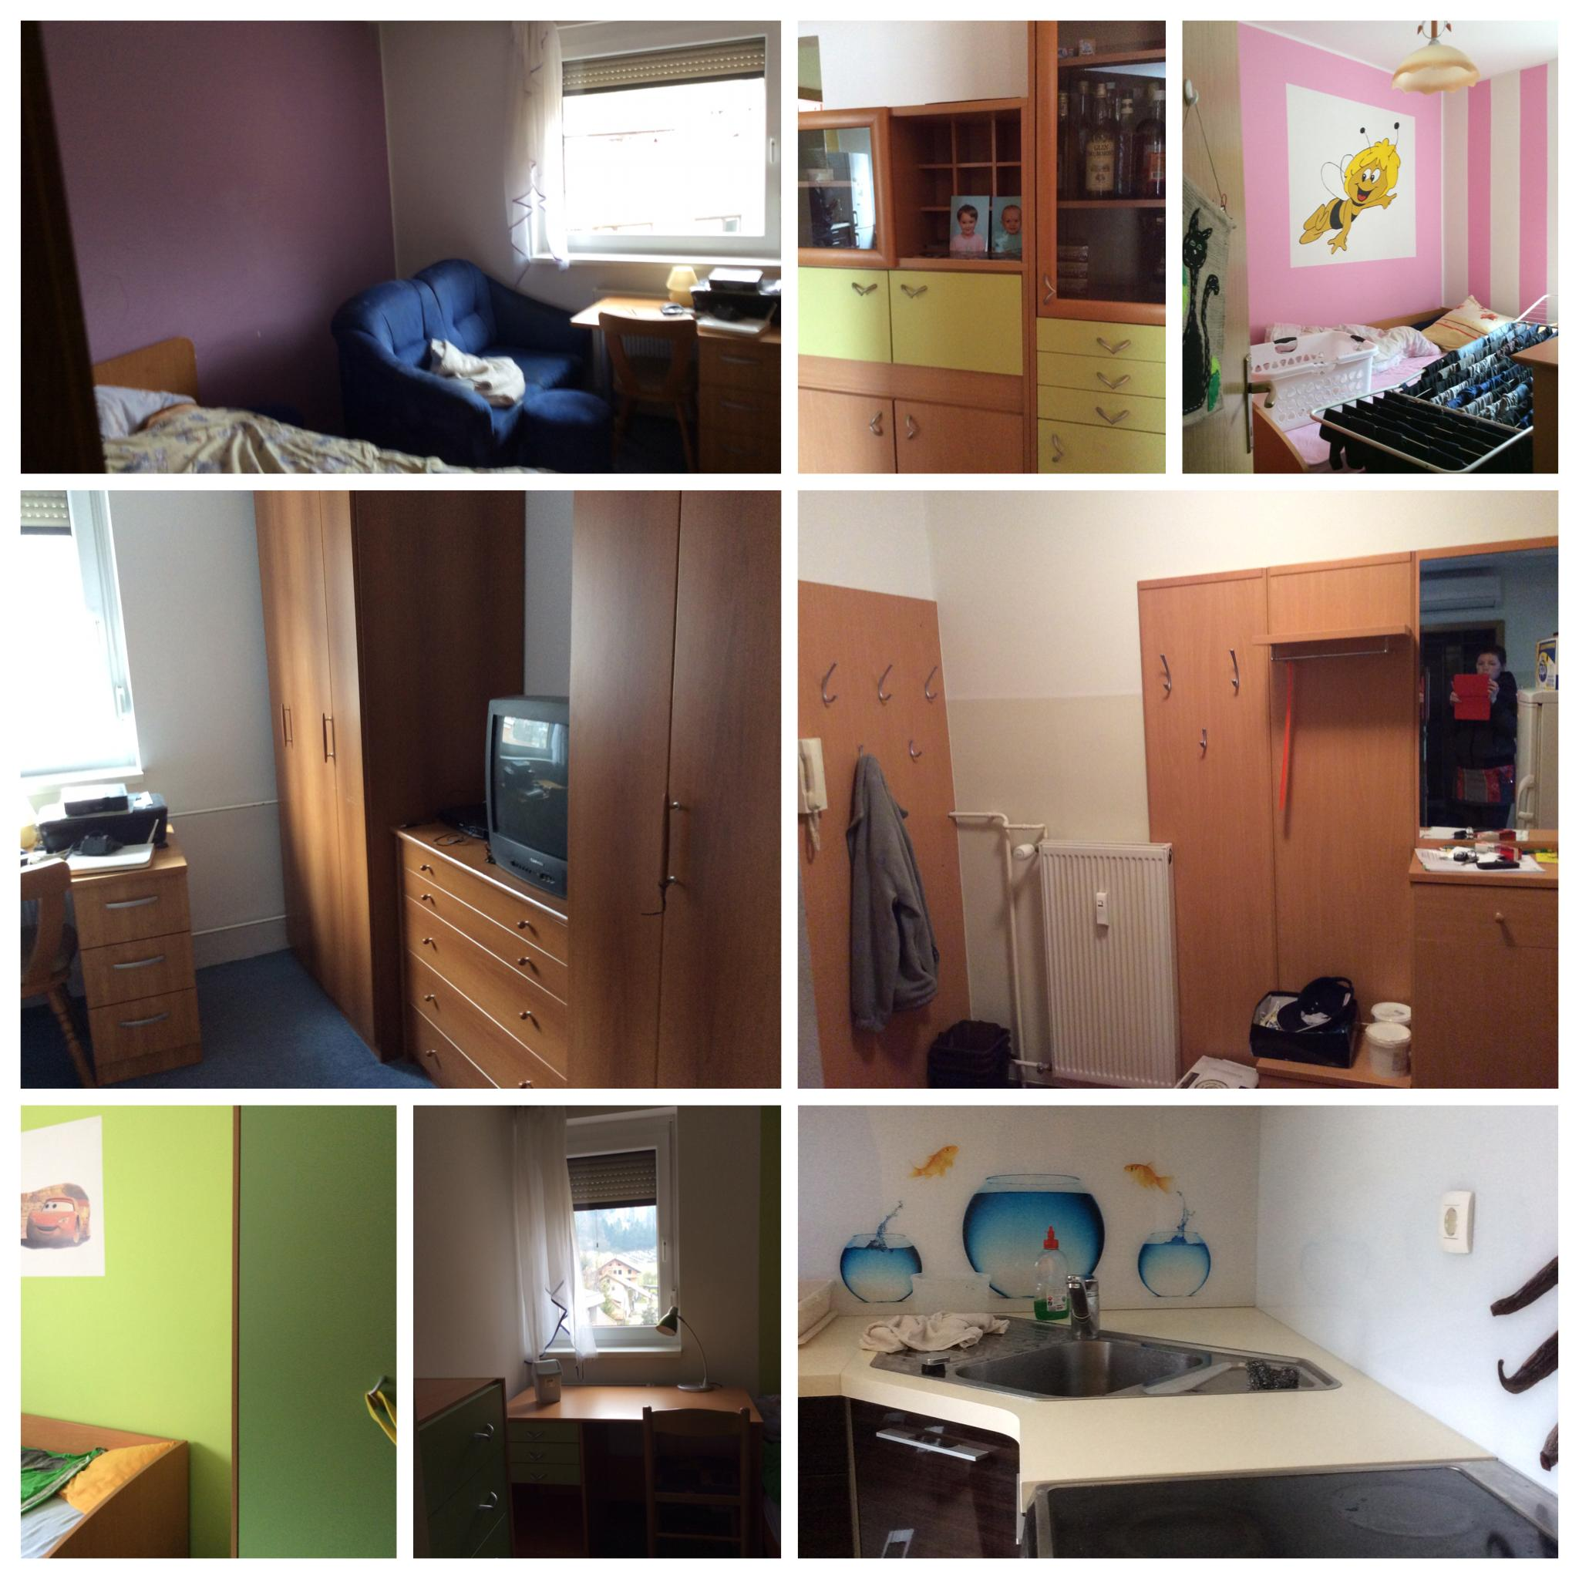
- EVS activity – travel costs are calculated by the ERASMUS+ regulations, if the travel costs exceed the amount (max 275 €), the extra is covered by the volunteer; accommodation is provided by the coordinating organization, volunteer will receive 85 € of pocket money and up to 170 € of food costs per month
- free days: 2 days off/week and 2 holidays/month are according to the regulations of the Programme Erasmus +

Accommodation and meals:
- EVS activity – apartment in a block of flats in Zagorje, shared with other EVS volunteers, walking distance to activity venues; volunteer cooks meals on his own

About Zagorje:
Zagorje is a municipality of 20.000 inhabitants, situated in the center of Slovenia and surrounded by green hills. There are schools, sport facilities and activities, a library, a cinema, shops, bars and coffee shops. Zagorje has good railway and highway connections with capital Ljubljana and other parts of Slovenia and neighboring countries.

More info:
SK: Ondrej Mäsiar, evs@mladiinfo.sk
SI: Nina Nahtigal, nina@mczos.si
Youth center:
www.mczos.si
www.mczos.si/evs-blog
www.facebook.com/mladinskicenter.zagorje
https://www.youtube.com/user/McZ0S

