Youth in Alzira for Nature Conservation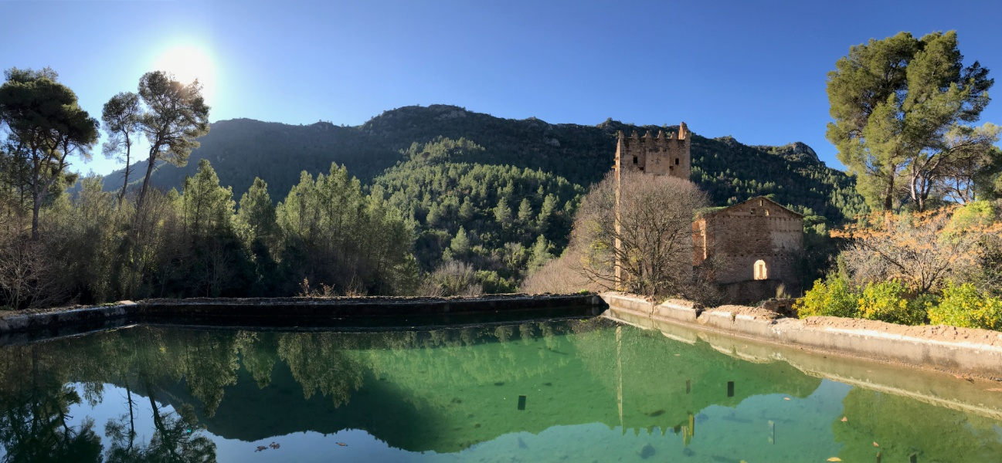

Call for: 1 person from Bulgaria, 1 person from France, 1 person from Slovakia
Place of European Solidarity Corps: Alzira, Valencian Community, Spain (40km away from Valencia)
Project: Environmental actions, eco-tourism, outdoor activities, eco-citizenship promotion
Duration: 6 months, starting in March 2018

Contact person: José Manuel Valls
Email: europa@alzira.es
Tel: +34 96 245 5101
Address: C/Sant Roc Nº6, Alzira, Spain
Organization: IDEA, City Council of Alzira
Guaranteed: Accommodation with single room and internet, food money, pocket money, CIGNA insurance, language course, travel allowance, mentor and supervisor

THE PROJECT
The Solidarity Corps Youth for Nature Conservation in Alzira will focus on the lead of on-site conservation actions for young Europeans in Alzira region.
The city and its surrounding benefit from relevant natural parks and sites (High hills, River side natural space). The volunteer will help the local public team from the city by bringing help on new point of view for the actions which need and/or should be needed.
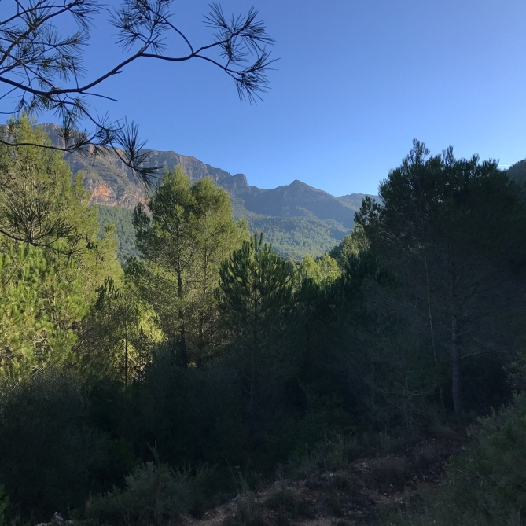
For the volunteer of solidarity corps interested in working in the future, in the field of nature conservation this project could be a great experience where he could gain a lot of competences. In the meanwhile, our organization stays open to any profile that is ready and motivated to work on environmental actions.
YOUR MISSION
Among the main missions who will be led by the volunteers are:
- Act as an active agent of communication on good practices of the public visitors in the green spaces
- Promote eco-citizenship
- Help and orientate the visitors in the nature reserve
- travel across a defined green space and inform the coordinator about any incident or irregularities
- help the environmental department in its daily projects preparation and management.
- By helping the local actors as a solidarity corps, young people ready to take concrete actions will have direct and indirect impacts on natural sites.
By helping the local actors as a solidarity corps, young people ready to take concrete actions will have direct and indirect impacts on natural sites.
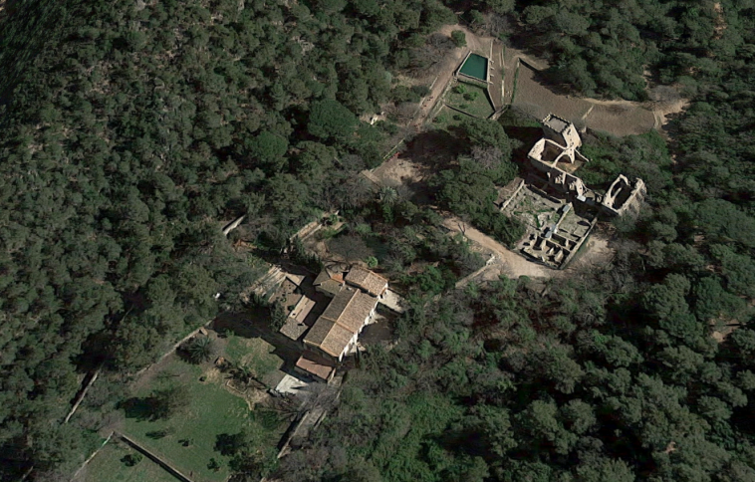 | 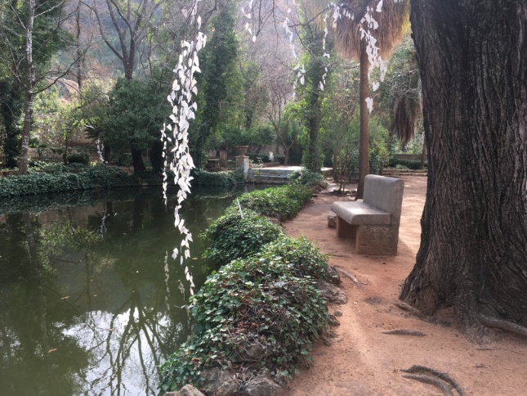

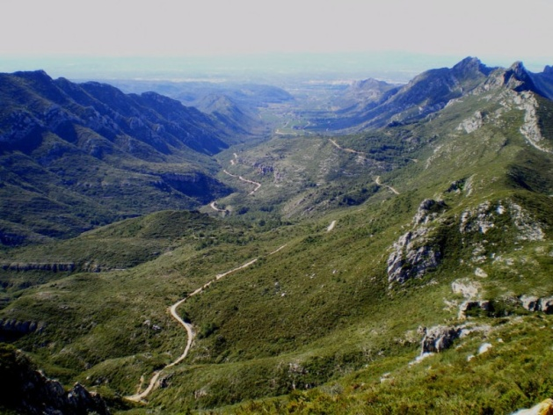
PHYSICAL CONDITION
As the some missions are involving on-site outdoor trips and giving the distance from the accommodation inside the city to the natural site (appr. 35min biking, the volunteer will need to climb up a hill), the volunteer should be in a good physical condition and take it into consideration the context of the project.

VOLUNTEER PROFILE
We are looking for young volunteer that are interested in outdoor activities. They should be open-minded and enthusiastic. An interest in nature conservation and environmental care will be appreciated. A basic level of Spanish and intermediate English are asked.
LANGUAGE COURSES
The volunteers will benefit from Spanish courses throughout the volunteering.
ACCOMMODATION, FOOD
Accommodation costs are fully covered by our organization. The volunteers will have to share one flat in Alzira, with individual bedrooms and access to all the facilities (fully equipped kitchen, washing machine, TV, WiFi, etc).
Every month volunteers will receive money for food (180€) and pocket money (105€).
The hosting organization also provides 3 bikes for volunteers.
TRAVEL EXPENSES AND INSURANCE
Your tickets will be reimbursed according to Erasmus+ rules after arrival to Alzira and after receiving all copies of boarding passes and other tickets.
Volunteers are covered by CIGNA insurance that is arranged by sending organization.

OUR TERRITORY
https://en.wikipedia.org/wiki/Alzira,_Valencia – General info about Alzira
http://en.comunitatvalenciana.com/ - Valencia Community touristic portal

ABOUT US
BLOG | idealmobility.wordpress.com
IDEA Alzira Movilidad Europea
@idea.alzira
@idealmobility

linkedin.com/in/ideaalzira/

Our department idea-alzira.com

