EUROPEAN VOLUNTARY SERVICE (EVS) in Vienna, Austria
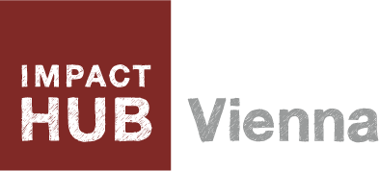
Call for: 2 young people (18-30) from Slovakia
Place of EVS: Vienna, Austria
Project: Community or Space team
Duration: 12 months, starting in February or March 2018
Address: Lindengasse 56, 1070 Vienna, Austria

Organization: Impact Hub Vienna, www.vienna.impacthub.net
Guaranteed: Accommodation, food, pocket money, insurance, travel, mentor, supervisor

Link:

Apply: with CV and motivation at evs@mladiinfo.sk

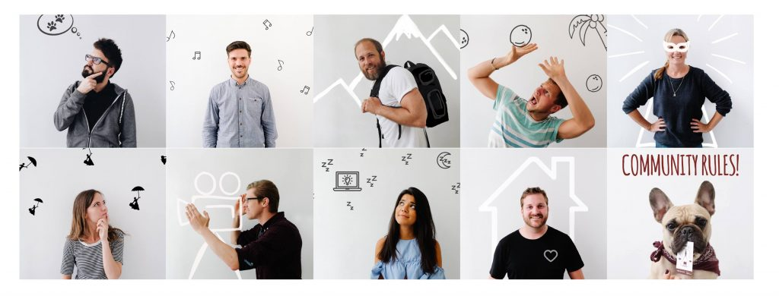

About the project

The project will last 12 months and will host 2 volunteers from Slovakia in Community or in Space team.

1. Community team
The volunteer will be working closely with the community team on community related activities, such as:
- Connecting and supporting members to realize their projects and ideas.
- Support the organization and setup of the diverse range of meetings, workshops and events planned at Impact Hub Vienna.
- Hosting Community Events
- Support the development of new membership services (e.g. Mentor-Program, Peer2Peer Learning, Success Board, Member Wall,…)
- Curate the members collaboration platforms (facebook group, internal member platform)
- Hosting the community and collaboration online
- Support the publishing of the internal newsletter together with the Communications Team
- Develop new Features for the community (e.g. Job Platform, Experts Platform,…)
- Support the member administration

2. Space team
The volunteer will be working closely with the space team on community and space related activities, such as:
- Welcoming visitors and new members, introducing the idea and the context of the space and provide background stories and relationships that shape the success of the Impact Hub.
- Providing information and assistance to members and visitors.
- Helping to set the right atmosphere and vibe together with the team of hosts.
- Support the management of the space, maintaining an inviting and inspiring place for people to work and connect.
- Support event and bookings team in event management and organization
- Support space operations incl. maintenance and development of infrastructure, security, office equipment and ICT infrastructure
- Maintain and enhance the aesthetics, create the environment or set the conditions that lead to more interaction and engagement with the space.
- Providing reception services, including answering phones and mails, post processing, opening and closing of venue

Additionally, by taking ownership the volunteer has the chance to develop her/his own project during his time at the Impact Hub Vienna during the EVS. The project will be co-designed with the Impact Hub Team and can be something that has personal relevance according to the volunteer’s personal passion or interests but is also connected to the overall mission and operations of the Impact Hub.

Conditions
The volunteer will participate with daily activities of the Impact Hub. They will work 7 hours a day from Monday to Friday (including 30 minutes of break). Saturdays and Sundays are free and volunteer has a right to have 2 days off per a month.
Accommodation, food (220 EUR/month), and pocket (115 EUR/month) money will be provided to volunteer.
Travel expenses (return ticket) will be reimbursed according to Erasmus+ rules after arrival to Vienna and after receiving all copies of boarding passes and other tickets.
Volunteers are covered by CIGNA insurance that is arranged by sending organization.
Main contact person (supervisor) for volunteers will be Barbara Inmann, Space Lead at Impact Hub Vienna.

Criteria

- Young people 18-30 years old.
- Knowledge of English language. German welcome but not a must.
- Hands-on, with good communication skills, willing to help.
- Interested in social entrepreneurship, startups, and co-working is a plus.
- Pro-active, communicative and motivated person.
- Experience as receptionist, in hospitality, tourism and / or facility management is an advantage.

Impact Hub Vienna

1200 m² co-working space and event location, business incubator, impact-driven community – We are where change goes to work!

Located in the beautiful 7th district at the heart of Vienna, we are a unique ecosystem of resources, inspiration, and collaboration opportunities that support the development of a more sustainable world.

The Impact Hub Vienna community is made up of social businesses addressing challenges both locally and globally. Our members are entrepreneurs, social investors, freelancers, advocates, campaigners, creatives, artists, consultants, coaches and more. Members enjoy a global platform connecting them to 15000+ like-minded entrepreneurs. They have access to training and support, work spaces, lectures, training workshops, community networking events and incubation programs. We are part of a global network of connected communities that enable collaboration. Impact Hubs unite people from every profession, background and culture with imagination and drive to pursue enterprising ideas for the world. These are the people who see and do things differently and have entrepreneurial passion to create sustainable impact.

Weekly Taks Overview
The daily tasks may vary in time and per week depending on the events / bookings and members that are in the space.
Monday | Tuesday | Wednesday | Thursday | Friday
Reception & Hosting in the space incl. welcoming and providing information to members, guests and bookers | Reception & Hosting in the space incl. welcoming and providing information to members, guests and bookers | Reception & Hosting in the space incl. welcoming and providing information to members, guests and bookers | Reception & Hosting in the space incl. welcoming and providing information to members, guests and bookers | Reception & Hosting in the space incl. welcoming and providing information to members, guests and bookers
Space checks & maintenance | Weekly internal host meeting | Space checks & maintenance | Weekly internal space team meeting | Space checks & maintenance
Support with organization of community events from space side | Support the event & bookings team with events in the space and organization of events with partners from all sectors | Create a space intervention that makes members connect and / or create an atmosphere of collaboration | Support the event & bookings team with events in the space and organization of events with partners from all sectors | Support with organization of community events from space side

