''Let Your Creativity Out” Short-Term EVS Project
(1st March 2019 – 30th March 2019)
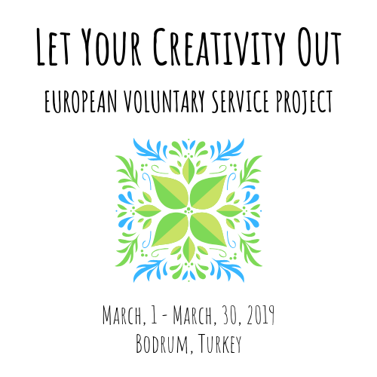
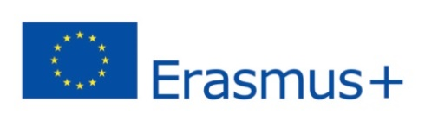
Application Form for EVS Volunteers
A. Personal information
Name/Surname
Address
Nationality |  |  | Country, city
Birth Date |  |  | Sending Organization
Email |  |  | Gender, smoker / non-smoker
Skype |  |  | Phone
B. Emergency contact
Surname | ( Mr / Ms ) |  | Name
Relativity
Email
Postal address |  |  | Phone
C. Profile of the volunteer
Have you ever taken part in an international event/organization as a volunteer before? If yes, please describe what were your tasks and responsibilities:
Have you ever attended any Erasmus+ Youth in Action Programme activity? If yes, please specify the type of
activity (youth exchange, training course, EVS/ESC) and the topic of the project:
Why did you choose Turkey for your short-term EVS? Bodrum Dance Club – Youth, Culture and Art Center? This project? Please explain your motivation:
Please share your personal expectations regarding this EVS Project: what do you plan to learn and gain during this project and how do you plan to use this experience in your professional career or daily life after the the project?
What is your relation with project theme? What can you offer and bring to the project?
Please describe what is volunteering for you:
Language skills. Please specify your language proficiency by underlining YES or NO answeres for the following questions:
Language: English

I can understand if someone speaks fluently, and I can reply fluently too – YES / NO
I can understand if someone speaks fluently, but my speaking skills do not allow me to reply fluently – YES / NO
I need assistance in understanding fluent speech and expressing myself – YES / NO

Language:

I can understand if someone speaks fluently, and I can reply fluently too – YES / NO
I can understand if someone speaks fluently, but my speaking skills do not allow me to reply fluently – YES / NO
I need assistance in understanding fluent speech and expressing myself – YES / NO

Anything else you would like to mention?
D. Additional Information
Please let us know if you have any special needs (allergy,diabetic,etc.):

Please e-mail the following materials with the completed application form to YOUR SENDING ORGANIZATION
They will send us all candidates’ forms

- 2 (two) high resolution pictures of you taking part in volunteering activities of any scale (local, national, international, etc.);

- Your Europass format CV in English (https://europass.cedefop.europa.eu/editors/en/cv/compose)

- Your Letter of motivation (1 page max.)

Send e–mail

